CANDIDATE NUMBER………………………………5004
CENTRE NUMBER…………………………………..080436
AN ‘A’ LEVEL COMPUTER SYSTEM DEVELOPMENT PROJECT WITH SPECIFIED REFERENCE TO COMPUTERIZATION OF

24

SUBMITTED TO THE:
ZIMBABWE SCHOOL EXAMINATION COUNCIL(ZIMSEC)
THIS MONTH OF OCTOBER 2024
AS PART OF THE REQUIREMENTS OF ‘A’LEVEL COMPUTER SCIENCE EXAMINATION SYLLABUS COMPONENT 6023


`
2024

MARCHWOOD SENIOR SCHOOL
7/16/2024

COMPUTER SCIENCE PROJECT
GAMING AND WILDLIFE MANAGEMENT SYSTEM.



COMFORTABLE

SECTION A…………………………………………………………………………………………………………………………………
BACKGROUND………………………………………………………………………………………………………………………………4
PROBLEM IDENTIFICATION…………………………………………………………………………………………………………4
INVESTIGATION OF A CURRENT SYSTEM …………………………………………………………………………………5
RESEARCH INSTRUMENTS……………………………………………………………………………………………………………5
QUESTIONNAIRES…………………………………………………………………………………………………………………5
INTERVIEW GUIDES………………………………………………………………………………………………………………………5
BROAD DESCRIPTION OF EXISTING SYSTEM…………………………………………………………………………….6
EVALUATION OF THE SYSTEM………………………………………………………………………………………………….6
REQUIREMENTS……………………………………………………………………………………………………………………………7
AIMS AND OBJECTIVES………………………………………………………………………………………………………………7
EVIDENCE OF RESEACH………………………………………………………………………………………………………………7
SECTION B……………………………………………………………………………………………………………………………….
CONSIDERATION OF ALTERNATIVE METHODS………………………………………………………………………….8
JUSTIFICATION OF METHODS OF SOLUTION…………………………………………………………………………9
INPUT DESIGN……………………………………………………………………………………………………………………………9
OUTPUT DESIGN……………………………………………………………………………………………………………………….13
TEST PLAN………………………………………………………………………………………………………………………………..13
SECTION C…………………………………………………………………………………………………………………………………
SYSTEM DEVELOPMENT……………………………………………………………………………………………………………..14
TECHNICAL DOCUMENTATION…………………………………………………………………………………………………..14
CODING AND LISTING………………………………………………………………………………………………………………16
SECTION D…………………………………………………………………………………………………………………………………
TESTING AND EVALUATION……………………………………………………………………………………………………….22
APPENDIX 1………………………………………………………………………………………………………………………………30
APPENDIX 2………………………………………………………………………………………………………………………………..31

SECTIONA:SELECTION, INVESTIGATION AND ANALYSIS

1 PROBLEM IDENTIFICATION AND BACKGROUND ANALYSIS

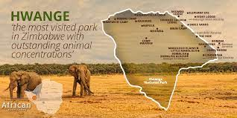

BACKGROUND

H
WANGE NATIONAL PARK IS A GAME PARK THAT IS LOCATED IN MATEBELELAND.IT WAS FOUND BY TED DAVISON IN SEPTEMBER 1928.THIS GAME PARK HAD MANY ANIMALS OF ABOUT 500 .MORE THAN 400 TOURISTS COME TO SEE ANIMALS AND THEY BRING FOREIGN CURRENCY.LATER IT WAS DISCOVERED THAT .ANIMALS SUCH AS LIONS AND ELEPHANTS HAD DECLINED RAPIDLY TO ABOUT 250 DUE TO POACHING.THEREFORE LEADING TO A DECLINE IN TOURISTS WHICH LED TO A DECLINE IN FOREIGN CURRENCY.

PROBLEM IDENTIFICATION
DUE TO LACK OF TIGHT SECURITY ,POACHER ARE DISGUISING THEMSELVES AS GAME RANCHERS AND THEY ARE KILLING ANIMALS .SINCE WORKERS ENTER THE GAME PARK WITHOUT BEING INSPECTED .THERE ARE HIGH CHANCES OF POACHERS ENTERING.THE SYSTEM SHOULD USE MICROSOFT ACCESS DATA FOR STORAGE OF EMPLOYEES RECORDS AND CHECK EVERY WORKER USING THE DATA THEY HAVE SO THAT THEY CAN REDUCE ENTRANCE OF POACHER ,VISUAL BASIC .NET FOR THE CALCULATION OF ANIMALS ON DAILY BASES SO THAT THEY DISCOVER SOON IF THEY IS A SHORTAGE OF ANIMALS. FOR DOCUMENTS USING MICROSOFT WORDING THE OPERATING SYSTEM WINDOWS 11 .THEY SHOULD NOW USE THE G.P.S. TRACKING SO THAT THEY COULD SEE WHERE THE ANIMALS GO , WHAT THEY ARE DOING . ALSO CAMERAS TO CHECK EVERY MOVEMENT AT THE PARK SO THAT THEY PRESERVE ANIMALS.

INVESTIGATION OF A CURRENT SYSTEM
- RESEARCH INSTRUMENTS
- QUESTIONNAIRES
- INTERVIEW

WHY THE RESEARCHER DECIDED TO USE THESE RESEARCH INSTRUMENTS
- THE RESEARCHER DECIDED TO USE THESE RESEARCH INSTRUMENTS BECAUSE THEY ALLOWED THE RESEARCHER TO COLLECT NON-VERBAL DATA,
DATA ACCURACY AND THEY IS RESPONDENT ANONYMITY.

- QUESTIONNAIRES : THE RESEARCHER USED QUESTIONNAIRES TO RECORD THE DETAILS OF EMPLOYEES E.G

- QUESTION | ANSWER
1.WHAT IS YOUR NAME? | ………………………………………
2.HOW OLD ARE U? | ……………………………………..
3.WHEN DID U START USING THE CURRENT SYSTEM? | ………………………………………
4.WHATS YOUR COMMENT ON ABOUT THE GAME PARK? | ………………………………………
5.HAVE YOU NOTICE ANY QUALITY CHANGES ON THE SYSTEM? | YES NO
6.IS THERE ANY NEED TO IMPROVE THE SYSTEM AGAIN? | YES NO
7.ARE YOU SATISFIED WITH THE GAMING SYSTEM? | YES NO
8.ARE YOU COMPUTER LITERATE? | YES NO
9.DO U HAVE QUALIFIED EMPLOYEES? | YES NO
10. IS POACHING REDUCED DUE TO THE SYSTEM? | YES NO

- INTERVIEWS :
THE RESEARCHER SHOULD INTERVIEW TO RESEARCH ON THE CAPABILITIES OF THE EMPLOYEES FOR EXAMPLE

QUESTION | ANSWER
1.WHAT IS YOUR NAME? | ………………………………………
2.HOW OLD ARE U? | ……………………………………..
3.WHEN DID U START USING THE CURRENT SYSTEM? | ………………………………………
4.WHATS YOUR COMMENT ON ABOUT THE GAME PARK? | ………………………………………
5.HAVE YOU NOTICE ANY QUALITY CHANGES ON THE SYSTEM? | ………………………………………
6.IS THERE ANY NEED TO IMPROVE THE SYSTEM AGAIN? | ………………………………………
7.ARE YOU SATISFIED WITH THE GAMING SYSTEM? | ………………………………………
8.ARE YOU COMPUTER LITERATE? | ………………………………………
9.DO U HAVE QUALIFIED EMPLOYEES? | ………………………………………
10. IS POACHING REDUCED DUE TO THE SYSTEM? | ……………………………………..

BROAD DESCRIPTION OF EXISTIING SYSTEM
- INPUT
WE INPUT TOTAL SECURITY, CAMERAS INORDER TO KNOW WHAT WILL BE HAPPENING AROUND PARK , ALL ACTIVITES BEING CARRIED OUT FOR EXAMPLE ,WHERE ANIMALS ARE GOING ,WHO IS ENTERING IN , PARK THE RANGER WITH THE ANIMALS AND WHAT IS HE DOING.

- PROCESS
TRACKING ANIMALS BY USING G.P.STRACKING DEVICES WHICH ARE PLACED ON THE ANIMAL SO THAT WE CAN TRACE WHERE EVER IT GOES ,RECORDING THE NUMBER OF ANIMALS SO THAT WE CAN TELL IF THEY IS A MISSING ANIMAL.CHECKING THE RANGER ON DUTY INORDER TO SEE IF HE IS PART AND PARCEL OF THE ORGANISATION COZ SOME CAN PRETEND TO BE A RANGER WHILE HE OR SHE IS NOT.

- OUTPUT
WE LOOK FORWARD TO HAVE MORE ANIMALS , MORE PROFIT FROM TOURIST WHO VISIT THE PARK , BECAUSE OF THE INPUTS LIKE CAMERAS WE CAN ACTUALLY SEE WHAT WILL BE HAPPENING AND POACHERS WILL REDUCE DUE TO TIGHT SECURITY ON THE PARK AND THEY CAN BE EASILY RECORNISED .

- STORAGE
OUR INFORMATION IS STORED IN COMPUTERS USING DATABASE , WORD . ALSO IN FLASH ,INFORMATION LIKE EMPLOYEE DETAILS ,ANIMAL RECORDS , TOURIST WHO CHECK IN AND OUT ON DAILY BASIS.

EVALUATION OF THE SYSTEM

- WEAKNESS
-THEY USED BOOKS WHEN RECORDING THE NUMBER OF ANIMALS AND ENTERING DETAILS OF EMPLOYEES.BOOKS WERE A DISADVANTAGE BECAUSE THEY NEEDED ENOUGH SPACE TO STORE THEM AND MORE LABOUR UNLIKE COMPUTERS WHICH ARE EASY TO USE.

- STRENGETHS
-BOOKS WERE AN ADVANTAGE ALSO ,WHEN THERE WAS NO ELETRICITY THEY USED BOOKS UNLIKE COMPUTERS THEY NEED ELECTRICITY TO FUNCTION.

REQUIREMENT FOR SPECIFICATION

- SOFTWARE REQUIREMENTS
- MICROSOFT WORD FOR WORD DOCUMENTATION OR PROCESSING
- MICROSOFT ACCESS FOR STORING DATA (DATABASE)
- (VB.NET) VISUAL BASIC FOR DESIDNING AN INTERFACE(PROGRAMING)
- ANTI-VIRUSES(SMADAV,AVAST) FOR PROTECTING THE COMPUTER FORM VIRUSES
- WINDOWS 7 or higher to host the system

- HARDWARE REQUIREMENTS
- C.P.Us
- MONITORS
- MOUSE
- TRACKING DEVICES
- KEYBOARDS
- HARD DRIVES
- CORE 9 , ITB ,32 GigROM
AIMS AND OBJECTIVES

- AIMS
-FAST AND EFFICIENT SYSTEM
- EASY TO ACCESS
-

- OBJECTIVES
- THE SYSTEM SHOULD BE ABLE TO:
- ADD OR DELETE NEW EMPLOYEES
- PRINT REPORTS

EVIDENCE OF RESEACH
REFER TO APPENDIX
FILLED IN QUESTIONNAIRES REFER TO APPENDIX 1
INTERVIEW SESSION REFER TO APPENDIX 2

SECTION B :DESIGN

CONSIDERATION OF ALTERNATIVE METHODS
THE RESARCHER CONSIDERED THE FOLLOWING METHODS
- OFF-THE-SHELL/GENERIC
- TAILOR-MADE SOFTWARE (BESPOKE/USER APPLICATION SOFTWARE )

OFF-THE-SHELL/GENERIC
THIS INVOLVES THE PURCHASE OF EXISTING SOFTWARE FROM THE MARKET.THE SOFTWARE IS READILY AVAILABLE AND IT IS CHEAPER TO BUY THAN TO DEVELOP.

ADVANTAGE
- THE SOFTWARE IS TRIED AND TESTED THEREFORE IT IS FREE FROM BUGS
- FAST TO IMPLEMENT
- SUPPORT SERVICES AVAILABLE ON THE INTERNET

DISADVANTAGES

- THE SOFTWARE MAY NOT FIT THE CLIENT NEEDS
- THE SOFTWARE MAY BE RIGID

TAILOR-MADE SOFTWARE (BESPOKE/USER APPLICATION SOFTWARE )
- THIS OPTION INVOLVES THE DESIGN OF A NEW SOFTWARE AFTER CONSIDERTIONS OF USER’S REQUIREMENTS SPECIFICATIONS.THE SOFTWARE WILL BE DESIGNED USING VB.NET FOR INTERFACE DESIGN AND CODING ,ACCESS FOR DATABASE AND WORD FOR DOCUMENTAION.

ADVANTAGE
- MORE INTUITIVE WHEN RECORDING/ ENTERING DATA.
- SOFTWARE IS MORE LIKELY TO ADDRESS THE NEEDS OF CLIENTS.
- IMPROVES MOTIVATION AMONGST WORKERS.

DISADVANTAGE
- PRONE TO ERRORS.
- TAKE TIME TO IMPLEMENT
- CAN BE EXPENSIVE TO DESIGN

.JUSTIFICATION OF METHODS OF SOLUTION
THE RESEARCHER RECOMMENDS TO DESIGN AN IN HOUSE SOFTWARE BECAUSE THE SOFTWARE IS LIKELY TO ADDRESS THE NEEDS OF THE CLIENTS.

INPUT DESIGN
DATA CAPTURE FORMS
-THESE ARE REGISTRATION FORMS WHICH ARE DESIGNISED USING MICROSOFT WORD FOR EMPLOYEES TO ACCESS THE SYSTEM BY PROVIDING THEIR DETAILS.
-THE EMPLOYEES WILL HAVE TO FILL THE FORM BY USING BARCODES.

WELCOME FORM

“WELCOME“

TO

HWANGE NATIONAL PARK

continue
exit

LOGIN FORM

LOGIN FORM

name

password

EXIT
LOGIN

- AFTER ENTERING DETAILS , THE MESSAGEBOX SHOW LOGIN SUCCESSFUL

MAIN MENU

MAIN MENU

Employee details
animals

login

exit
About the system

FOR EXAMPLE IF YOU CLICK EMPLOYEE DETAILS IT SHOULD DISPLAY THE EMPLOYEE DETAILS FORM.

EMPLOYEE DETAILS

EMPLOYEE DETAILS

name

surname

ID

address

contact

EXIT
CONTINUE

ATTRIBUTE | DATA TYPE | FIELD SIZE
NAME | TEXT | 20
SURNAME | TEXT | 20
ID NUMBER | NUMBER | 05
ADDRESS | NUMBER | LONG INTERGERS
CONTACT | NUMBER | 04

OVERAL PLAN
HWANGE NATIONAL PARK

WELCOME

LOGIN

MAIN MENU EXIT

EMPLOYEES  DETAILS | ANIMALS | HELP | ABOUT THE  SYSTEM

ENTER | VIEW | ENTER | VIEW
SELECT | ENTER | EXIT | ENTER
EXIT | EXIT |  | EXIT

TIME FRAME
- INORDER TO FINISH SECTION A OF THE SYSTEM IT SHOULD TAKE ABOUT SIX WEEKS .
- AS FOR SECTION B IT TOOK ABOUT 2 MONTHS TO DEVELOP THE SYSTEM.

OUTPUT DESIGN

- SPECIFICATION OF REQUIRED OUTPUT
-OUR SYSTEM LOOKS FORWARD TO HAVE A DATA OUTPUT FORMAT WHICH IS SMART AND SCREEN DISPLAYS.

LOGIN FORM
LOGIN FORM

audreybell
name

2005
password

EXIT
LOGIN

MAIN MENU

MAIN MENU

Employee details
animals

About the system
exit

EMPLOYEE DETAILS

EMPLOYEE DETAILS

joseph
name

nkala
surname

123
ID

234
address

0786294808
contact

exit
continue

TEST PLAN

NAME OF TEST:CORRECT NAME ,PASSWORD
DESCRIPTION:USER INPUTS/ENTERS CORRECT LOGIN CREDENTIALS
OUTCOME:LOGIN SUCCESSFUL

NAME OF TEST: ADDING EMPLOYEE DETAILS TO THE SYSTEM.
DESCRIPTION: USER INPUTS/ ADD CORRECT EMPLOYEE DETAILS.
OUTCOME:RECORD ADDED SUCCEFULLY

SECTION C : SYSTEM DEVELOPMENT
TECHNICAL DOCUMENTATION

- PSEUDOCODE
- FOR LOGGING IN THE SYSTEM
ENTER USERNAME AND PASSWORD
IF PASSWORD IS CORRECT
THEN
OPEN MENU FORM
ELSE
SHOW ERROR MESSAGEBOX :SHOW “PASSWORD INCORRECT ,PLEASE TRY AGAIN”
ENDIF

- FOR MAIN MENU
ENTER USERNAME AND PASSWORD
IF NAME AND PASSWORD CORRECT ?
THEN
DISPLAY “ WELCOME TO HWANGE NATIONAL PARK”
THEN
DISPLAY “OPTIONS”
THEN
DISPLAY “ SELECT OPTIONS”
ELSE
START AGAIN
ENDIF

FLOWCHART: FOR THE SYSTEM

START

NAME,
PASSWORDDDDD

“WELCOME TO HWANGE NATIONAL PARK “
IS NAME AND
PASSWORD
CORRECT ?

NO YES

DISPLAY
OPTIONS
EXIT

SELECT OPTIONS

STOP

CODE / PROGRAM LISTING

LOGIN CODE: WHEREBY THE USER ENTERS HIS OR HER NAME AND PASSWORD
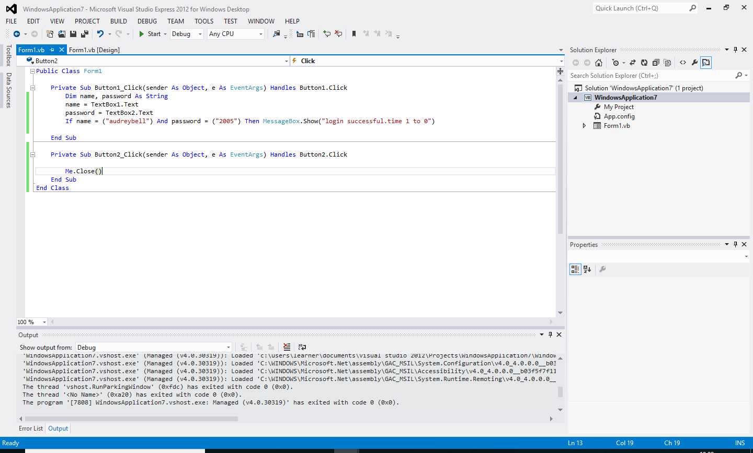

MAINMENU CODE: THE USER WILL SELECT WHICH SECTION TO FOCUS ON .
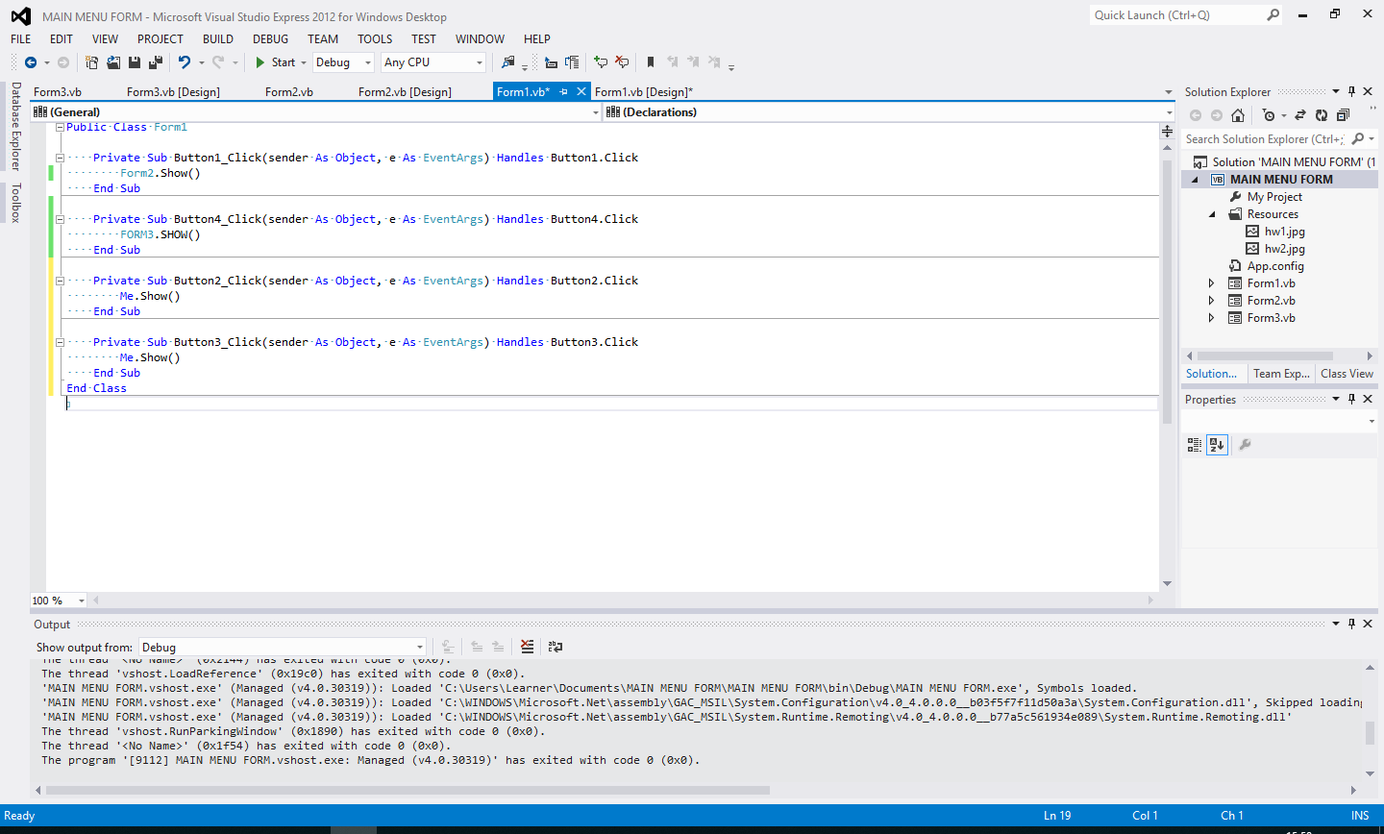

EMPLOYEE DETAILS CODE: WHEREBY THE EMPLOYEE ENTERS HIS OR HER DETAILS AND SHOWS HOW TO EXIT THE SYSTEM
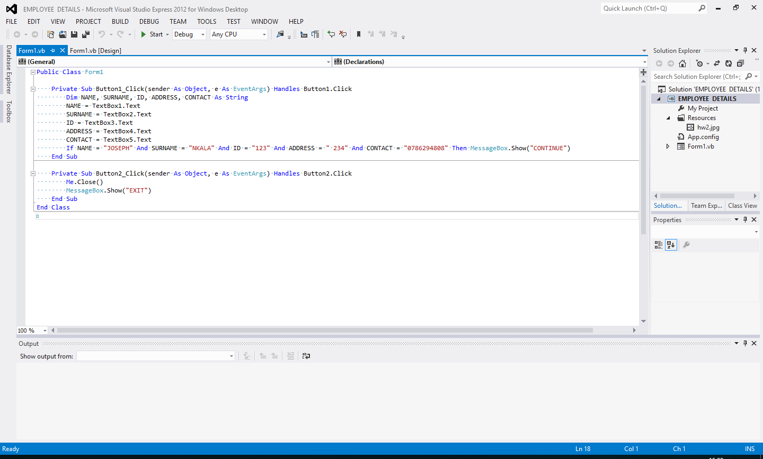
USER DOCUMENTATION
Installation Instruction
- Insert the provided compact disc into your compact disc drive. Go to my computer and copy all the contents of the disc into a new folder in your program files directory. Some operating systems may prompt you to confirm this action, if so select continue. After this has been done, open the folder, find the folder named “bin”. Open the folder. Right click on the file“GAMING AND WILDLIFE MANAGEMENT.exe” and select send to, form the drop down menu, and select “Desktop (shortcut).” Close all windows. On your desktop, you should now have a shortcut referring to the installation. Double click this shortcut to run the program.
- To run the GAMING AND WILDLIFE MANAGEMENT on the computer, installation is required from the medium provided.
Follow the step attentively
STEP1

Double click here

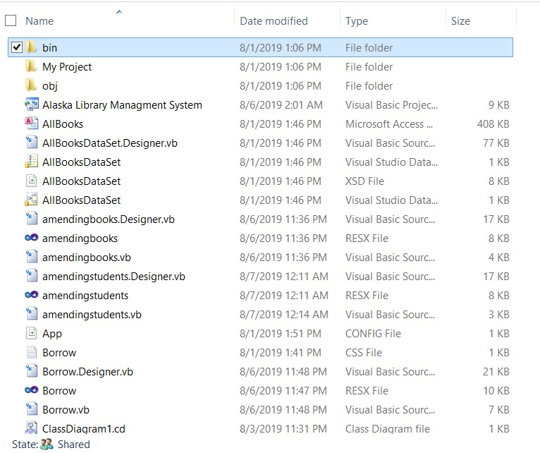

Step 2
Double Click here

Step 3
Double Click here

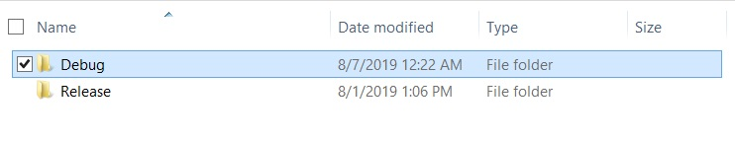
Running the system
To run the system the user must follow the following steps:
Step 1
- Click the short cut on the desktop

LOGINNG IN SYSTEM
Login FORM
- AFTER ENTERING DETAILS THE MESSAGE BOX DISPLAYS “ LOGIN SUCCESSFUL”
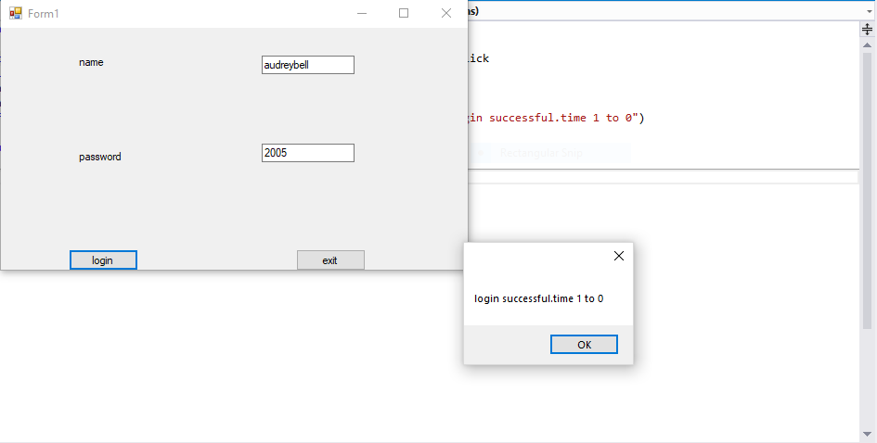

MAIN MENU FORM
- SELECTED OPTION(EMPLOYEE DETAILS) ON THE MAIN MENU FORM
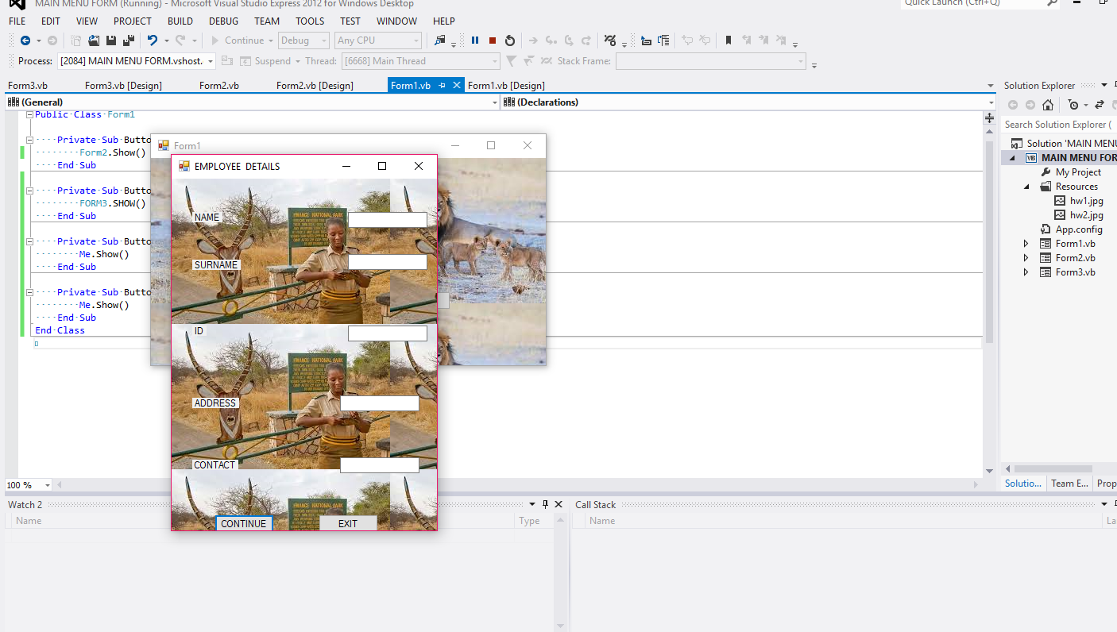

- EXITING OF THE MAIN MENU FORM

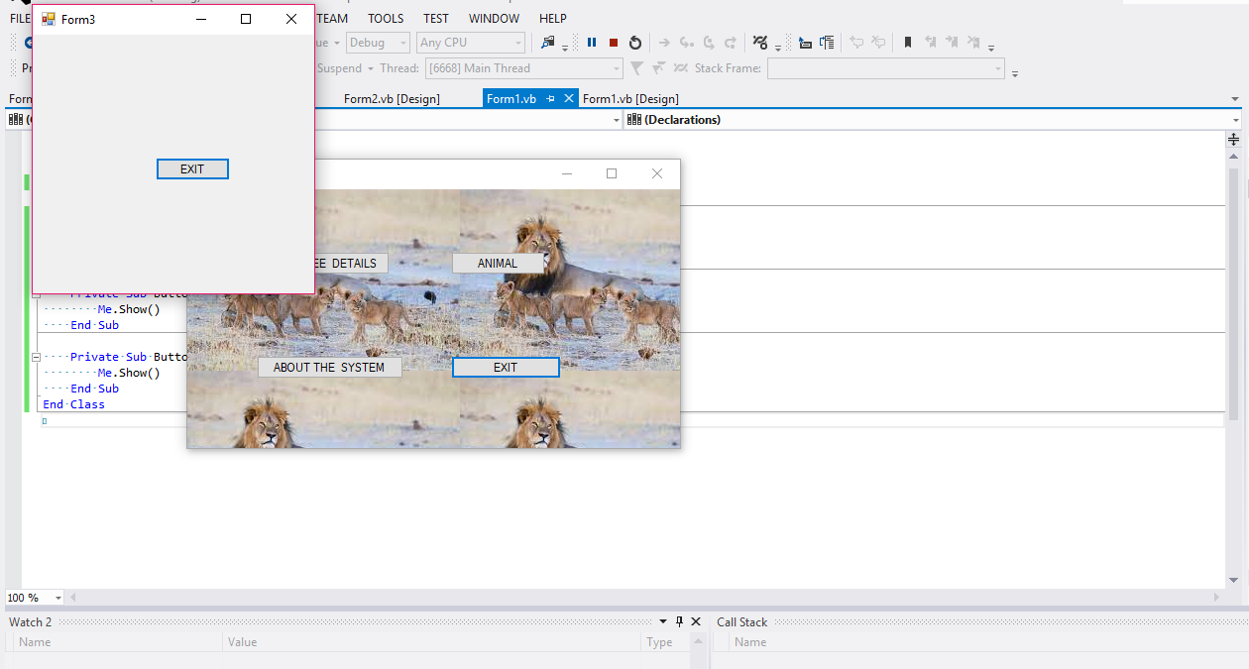

EMPLOYEE DETAILS FORM
- AFTER DISPLAYING THE EMPLOYEE DETAILS THE MESSAGE BOX DISPLAYS “CONTINUE”
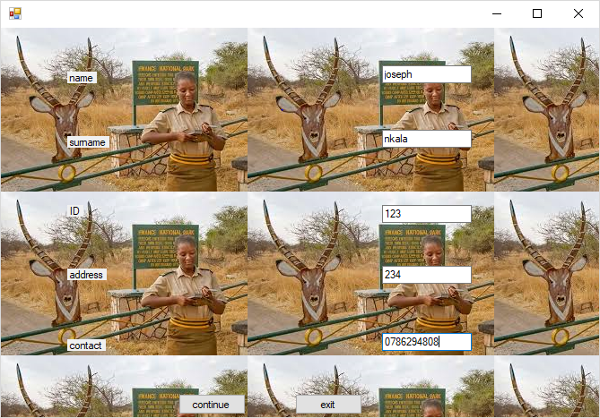
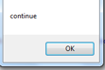

AFTER DISPLAYING “CONTINUE” YOU CAN EXIT THE EMPLOYEE DETAILS FORM.

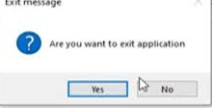

SECTION D:TESTING AND EVALUATION

USER TESTING

TESTING FOR STANDARD DATA
- STANDARD DATA IS DATA WITHIN THE RANGE OF HWANGE NATIONAL PARK ,EMPLOYEES DETAILS.

FIELD | DATA TYPE | TEST DATA | EXPECTED RESULTS
NAME | TEXT | JOSEPH | ACCEPT: CORRECT FORMAT & DATA TYPE
SURNAME | TEXT | NKALA | ACCEPT:CORRECT FORMAT& DATA TYPE
ID | NUMBER | 123 | ACCEPT:CORRECT FORMAT & DATA TYPE
ADDRESS | NUMBER | 234 | ACCEPT:CORRECT FORMAT &DATA TYPE
CONTACT | NUMBER | 0786294808 | ACCEPT:CORRECT FORMAT & DATA TYPE

TESTING FOR ABNORMAL DATA
- ABNORMAL DATA IS DATA OUTSIDE THE INPUT RANGE OF HWANGE NATIONAL PARK THAT IS NOT PROCESSED.ERROR MESSAGE AERE DISPLAYED WHEN ABNORMAL DATA IS INPUT.
INCORRECT PASSWORD. PASSWORD MUST CONTAIN TEXT INCLUDING NUMBERS.

SCREEN LAYOUTS


IF PASSWORD AND USERNAME CORRECT.USER LOGGED IN THE SYSTEM

EVALUATION OF THE COMPUTERIZED SOLUTION

ACHIEVEMENTS
- THE COMPUTERIZED SOLUTION HAS BEEN ABLE TO IMPROVE ON AND TACKLE MOST THE SET OBJECTIVES .THE NEW SYSTEM
- HAS GREATLY REDUCED STORAGE SPACE THROUGH THE USE OF HIGH CAPACITY DISK STORAGE MEDIUM.
- HAS MADE IT EASY TO SEARCH FOR RECORDS THROUGH THE USE OF KEY FIELDS E.G PURCHARSE PRICE AND FINES HENCE REDUCING CALCULATIONS ERRORS AND INCREASING THE ACCURACY OF ALL CALCULATIONS
- THERE IS AUTOMATIC PRODUCTION OF REPORTS E.G BOOK ENQUIRY REPORT AND CURRENT STOCK REPORTS
- ALLOWS OUTPUT OF INSTANT REPORTS SINCE SINGLE RRECORDS ARE QUERIED DIRECTLY FROM DATABASE.

OPPORTUNITIES FOR FURTHER DEVELOPMENT
- ENABLE APPENDING WRONG INPUT IN ONE FILE TO THE CORRECT AFTER BREAKING A VALIDATION RULE

APPENDIX
APPENDIX 1: QUESTIONNAIRES
QUESTION | ANSWER
1.WHAT IS YOUR NAME? | ……JOSEPH…………………………………
2.HOW OLD ARE U? | …………25…………………………..
3.WHEN DID U START USING THE CURRENT SYSTEM? | ……JAN 2023…………………
4.WHATS YOUR COMMENT ON ABOUT THE GAME PARK? | …SECURED PARK……………………………………
5.HAVE YOU NOTICE ANY QUALITY CHANGES ON THE SYSTEM? | YES NO  - *********
6.IS THERE ANY NEED TO IMPROVE THE SYSTEM AGAIN? | YES NO
7.ARE YOU SATISFIED WITH THE GAMING SYSTEM? | YES NO
8.ARE YOU COMPUTER LITERATE? | YES NO
9.DO U HAVE QUALIFIED EMPLOYEES? | YES NO
10. IS POACHING REDUCED DUE TO THE SYSTEM? | YES NO

APPENDIX 2:INTERVIEWS
QUESTION | ANSWER
1.WHAT IS YOUR NAME? | …LISA……………………………
2.HOW OLD ARE U? | ……25………………………………
3.WHEN DID U START USING THE CURRENT SYSTEM? | …………2022……………………
4.WHATS YOUR COMMENT ON ABOUT THE GAME PARK? | ……………HEALTLY WILDLIFE……………………
5.HAVE YOU NOTICE ANY QUALITY CHANGES ON THE SYSTEM? | …FAST SYSTEM…………………………
6.IS THERE ANY NEED TO IMPROVE THE SYSTEM AGAIN? | NO NEED………………………………………
7.ARE YOU SATISFIED WITH THE GAMING SYSTEM? | YES I AM SATISFIED……………………
8.ARE YOU COMPUTER LITERATE? | ……YES ………………………………..
9.DO U HAVE QUALIFIED EMPLOYEES? | …WE DO HAVE…………………………………..
10. IS POACHING REDUCED DUE TO THE SYSTEM? | ………INDEED IT IS………………………………

